

|  |  |  |
| --- | --- | --- |
| S No | Team | Resource |
| 1 | Lead | Lakshminarayana T |
| 2 | CSM | Pinaki Mallick |
| 3 | ETL | Divya Balakrishnan /Ashok Velu |
| 4 | MSTR | Nageswari Ganapathy |
| 5 | QA | Kishore Mantha |



Summary: Track the Application and it’s details in an Orderly manner, ‘Global Data Privacy Report’ grouping have been calculated based upon the certain logics and grouped respectively. Maintain the life cycle of the Application with all details such as Owning Organization, Asset Owner, GDPR Grouping, GDPR Relevant Flag, Hierarchy.

Below are the attributes/metrics where logics are different than usual.



Metric Definitions:



Grace Period Logic :



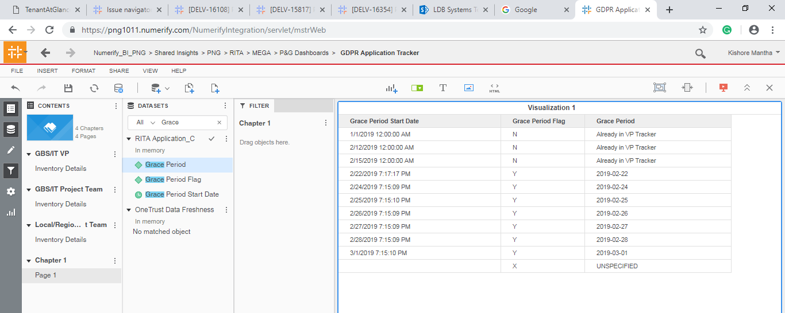

GDPR Application Tracker VI :

Three Tabs. Only Filter variations on the Grace period

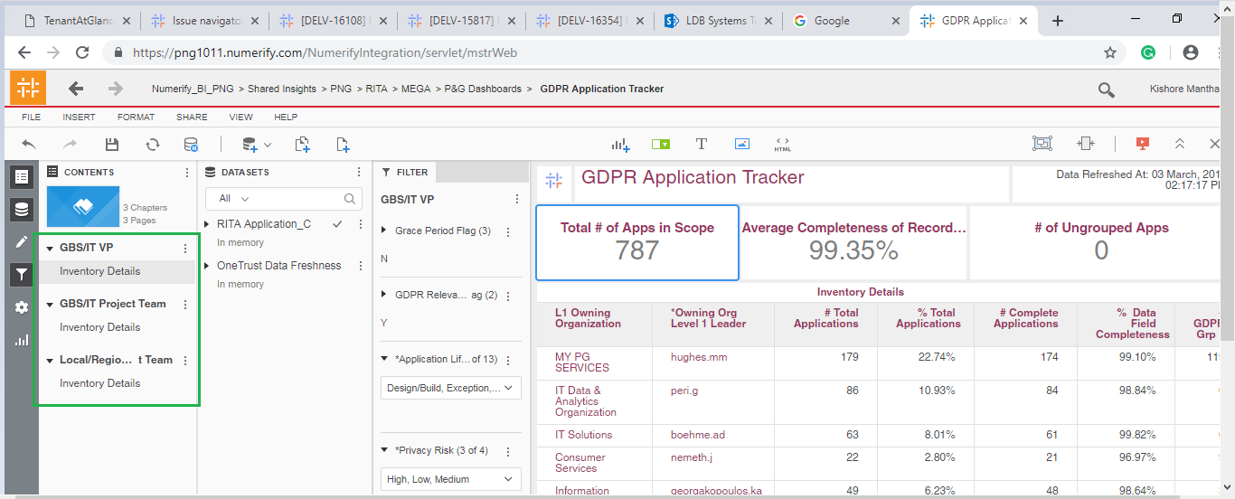

PFA for the Details :

